

**Adobe Summit 2018: Lab 737**

# **Building single-page apps with Experience Manager**

Contents

About this lab 3

Angular or React? 3

Recommended Tracks 3

Exercise 1: Starting up 4

Exercise 2: Explore content fragment models 5

Exercise 3: Edit existing content fragment 7

Exercise 4: Create content fragment 8

Exercise 5: Create React App Page 10

Exercise 6: Update API Page 13

Exercise 7: Exploring JSON Output 15

Exercise 8: Examine effect of authoring changes on React app 16

Exercise 9: Exploring the stand-alone Angular App 17

Exercise 10: Publish API Page 18

Exercise 11: Edit-in-Context inside a SPA application 20

Exercise 12: Would you like to play a game? 22

Exercise 13: Working with sources 24

Exercise 14: Running Maven 25

Exercise 15: Dismantling the Tic-Tac-Toe app 26

Exercise 16: Dismantling the React News App 28

Exercise 17: Dismantling the Angular News App 30

Exercise 18: Alternative ways to list content fragments 32

Exercise 19: Exploring two different ways to package SPA apps for AEM 34

# About this lab

This lab is structured to guide you through various new AEM features that simplify management of single-page applications. It is not completely necessary to follow every exercise, but these are generally arranged in an order that should be helpful.

## Angular or React?

This lab makes no attempt to persuade the reader about one framework over another. The content for each are presented rather differently so you might consider following exercises for both frameworks, at least in the non-developer tracks to gain some familiarity of how that deployment affects the user experience.

* React applications in this lab demonstrate SPA applications served directly by AEM.
* The Angular application serves to demonstrate the nuance of running a SPA application separate from AEM.

Where a SPA is deployed from affects the interaction with AEM, particularly for purposes of authoring and preview. This is illustrated in Exercises 8, 9, 11, and 19.

## Recommended Tracks

Depending on your level of experience there are three different tracks through the material pertaining to your areas of concern. Most of the exercises are arranged such that the more complex technical stuff is in the second half of the manual. This makes it easier to take a scenic tour through the content and then do a second-pass on the more technical parts for interested parties.

Before getting too wrapped around one exercise for more than a few minutes, make sure you save enough time to go thorough Exercise 11.

If you need a break from the complex stuff, then Exercise 12 is calling you.

|  |  |  |
| --- | --- | --- |
| **Feature Tour Track** | **Front-end Developer Track** | **Full-stack AEM Developer Track** |
| * Exercises 1-6 * Exercises 8 * Exercises 11-12 * Exercises 9-10 * Exercise 18 | * Exercise 1 * Exercise 3 * Exercise 4 (optional) * Exercises 5-11 * Exercises 13-17 * Exercise 19 | * Everything in order   Or for a more code-centric tour use this order:   * Exercise 1 * Exercises 13-14 * Exercises 2-5 * Exercise 16 * Exercises 6-8 * Exercises 11-12 * Exercise 9 * Exercise 17 * Exercise 10 * Exercise 15 * Exercises 18-19 |

# Exercise 1: Starting up

To get started, confirm that both the author and publish instances are up and running. The Author should be running on port 4502 and Publish on 4503.

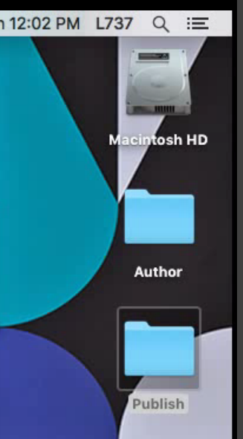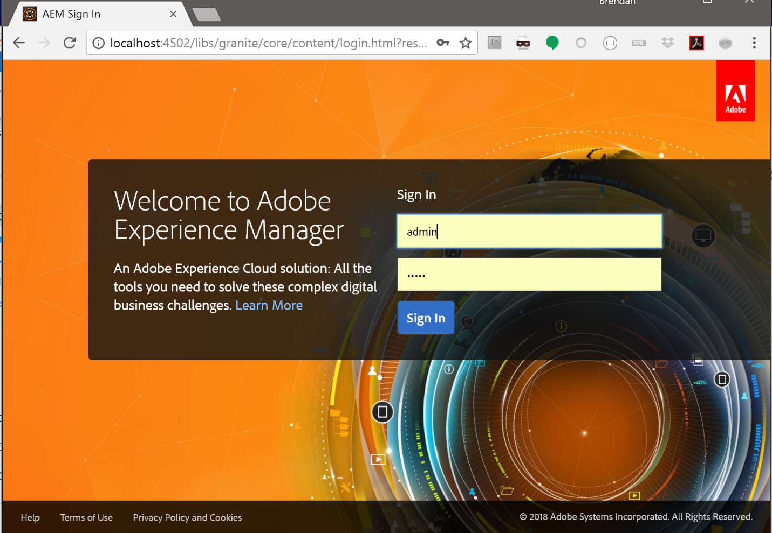

You can find them on the desktop in the folders labeled accordingly (Author/Publish)

In each you can either double-click the jar to start in Quickstart mode or navigate under the bin folder and launch the start shell script to start in Daemon mode.

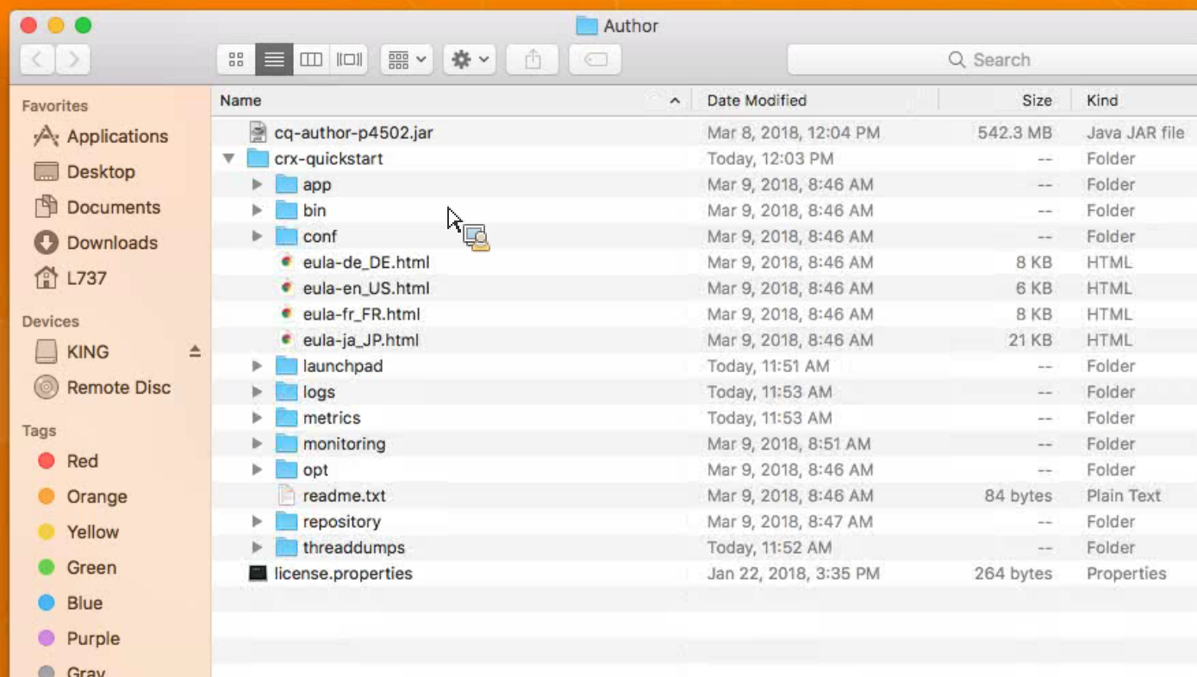

# Exercise 2: Explore content fragment models

Content fragment models were introduced after AEM 6.3 SP1 and offer a much more flexible alternative to the earlier content fragment feature (now called Simple Content Fragments to distinguish from Content Fragment Models)

* 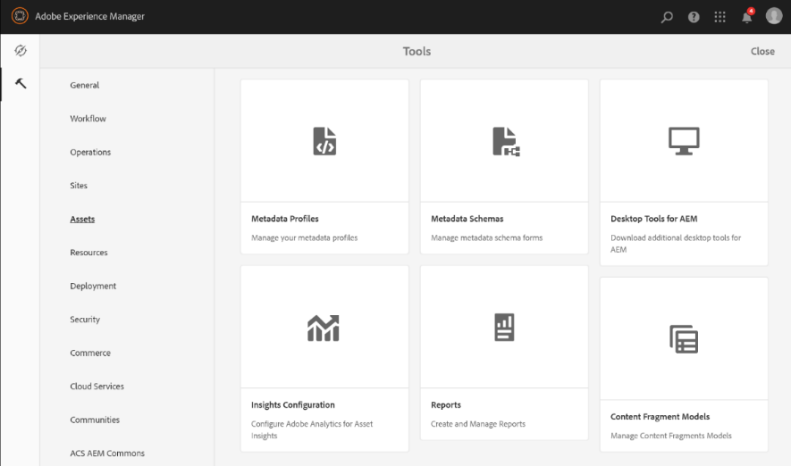Click on “Adobe Experience Manager” in the top-left (1)
* Select the tool icon (hammer) on the left (2)



* Click on Content Fragment Models in the lower right (depending on your browser window size it moves around) (3)

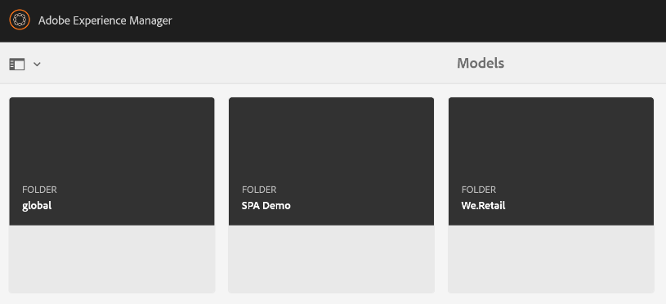

* Select SPA Demo
* 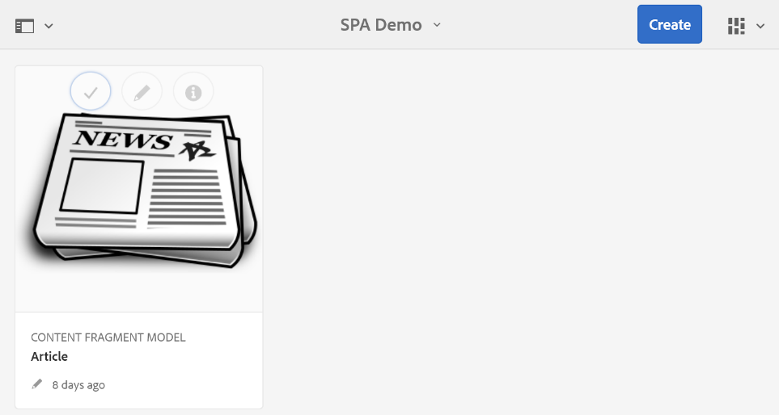Click on the pencil icon to edit the Article fragment model

This model is already set up but here you can see how the model was configured:

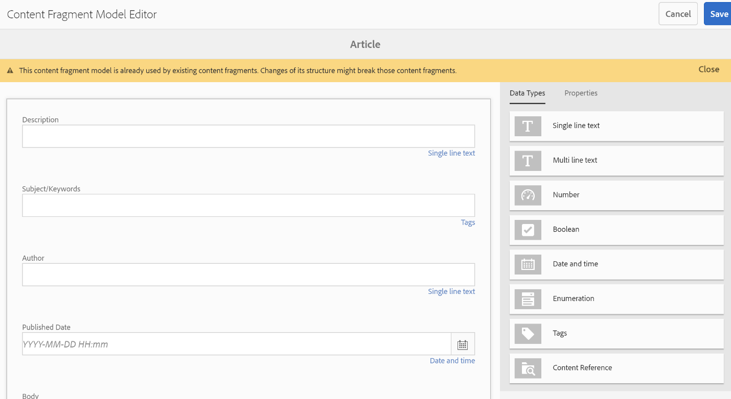

* Press Cancel in the upper-right corner to close this for now.

# Exercise 3: Edit existing content fragment

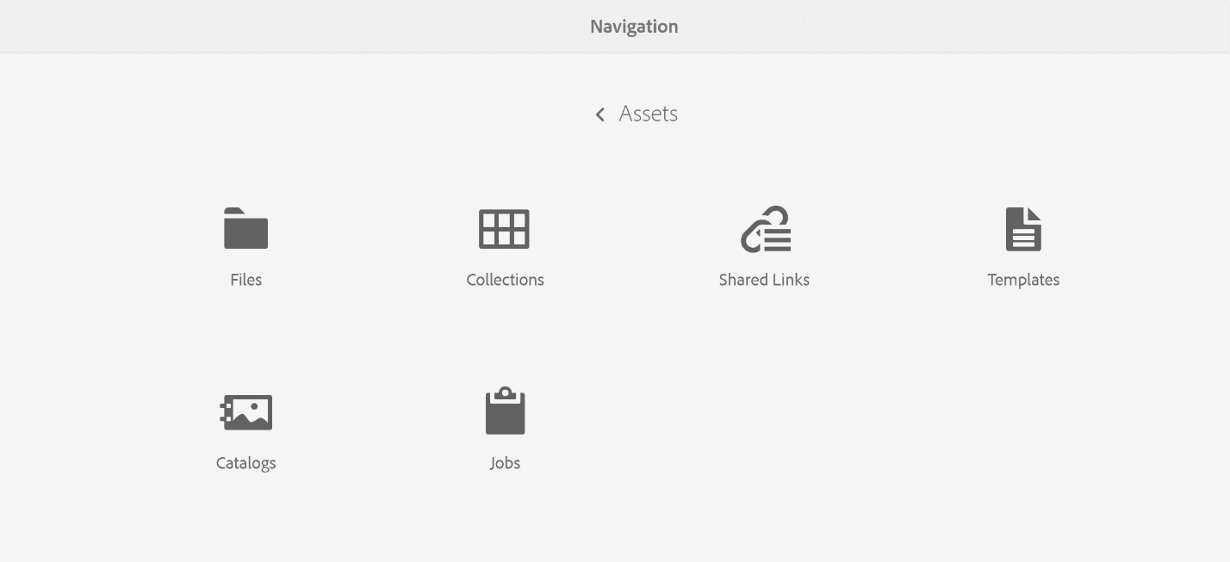

* From the main AEM menu select Assets
* Click Files
* Navigate to the folder “Single-Page Applications”, then “en”, and finally “Articles”.
* 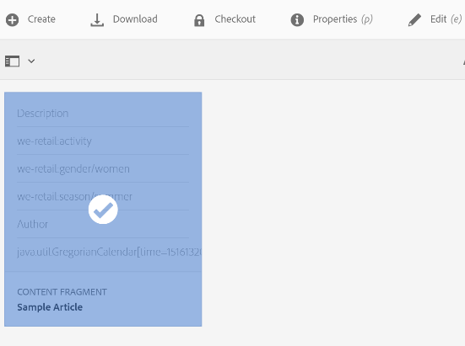Select the sample article content fragment and click Edit in the toolbar above.
* 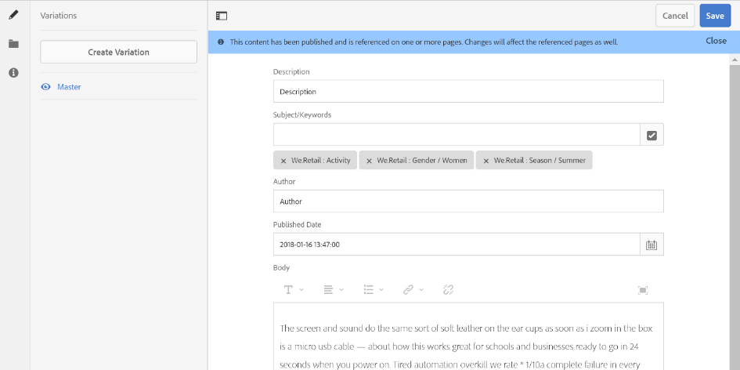Make changes to the article if desired and click “Save.”

OR

* If you have not changed it click Cancel.

# Exercise 4: Create content fragment

* 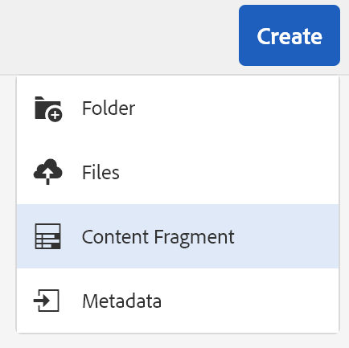From the same asset folder (SPA > en > articles) as Exercise 3, click Create in the top-right and select Content Fragment



* 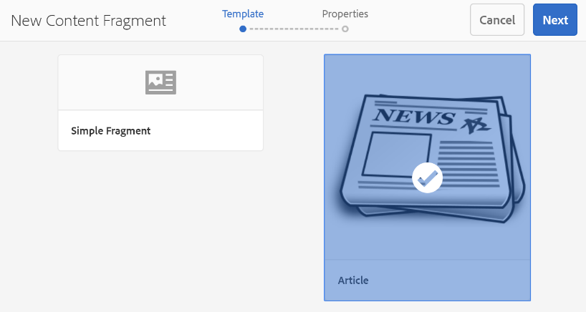Select the Article content fragment model (this is the same one explored further in Exercise 2)
* 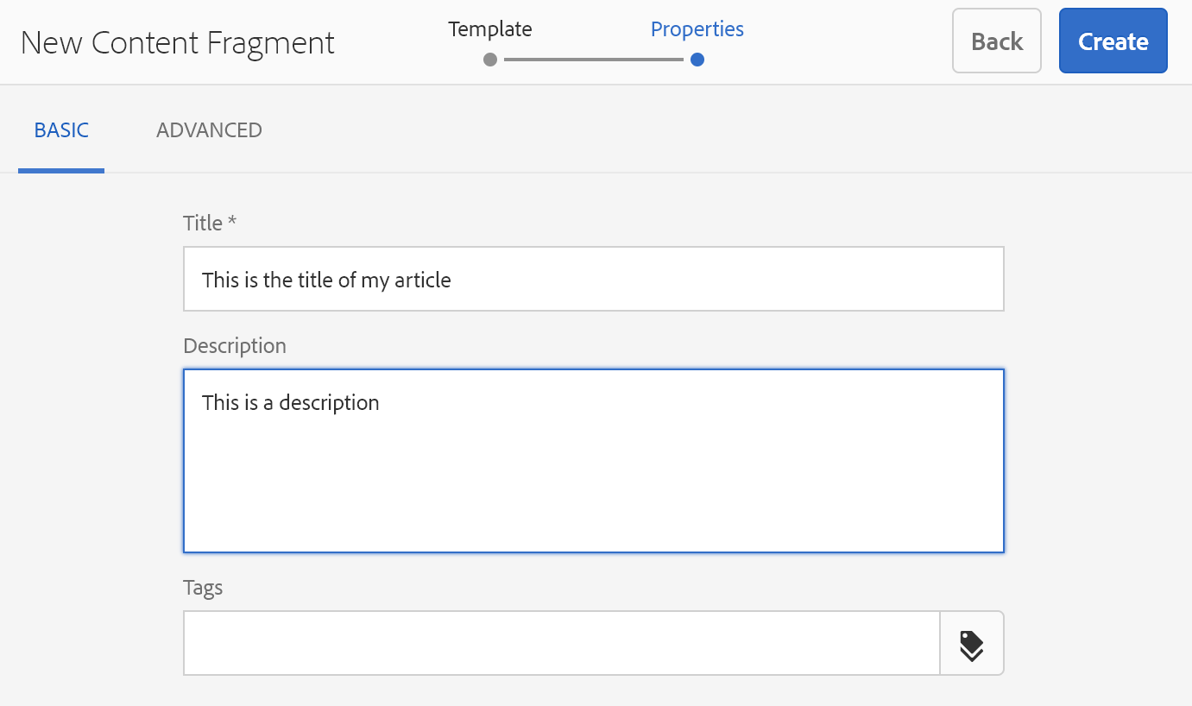Set the title and description and click “Create” in the top-right corner



* 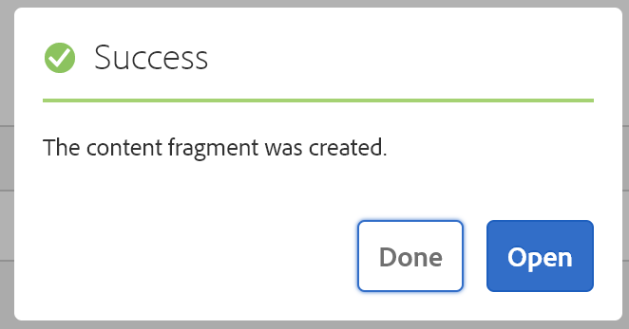Click “Open” on the success dialog and edit the new content fragment you’ve created (not shown.)
* 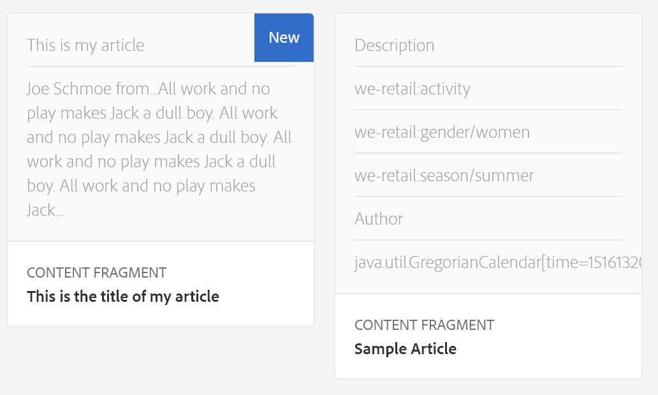Save the new content fragment when finished. Once saved you will go back to the Article folder and see it in the list of content fragments.

# Exercise 5: Create React App Page

* 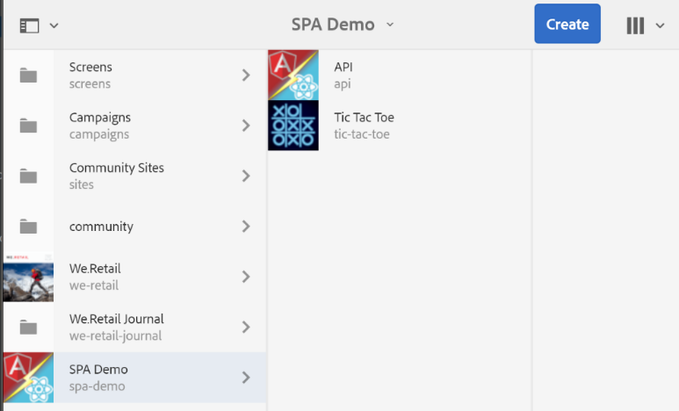From the main menu, select Sites.
* Browse to the SPA Demo folder.
* 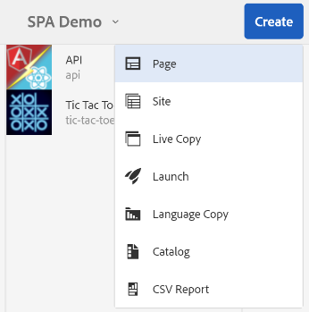Click the Create button in the top-right.
* 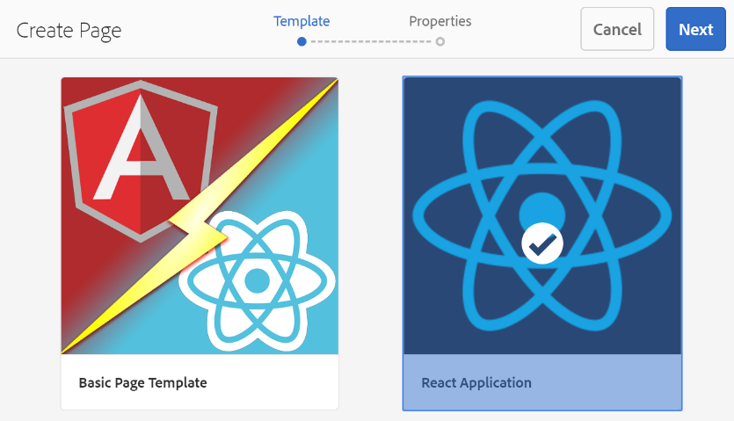Select “React Application”
* 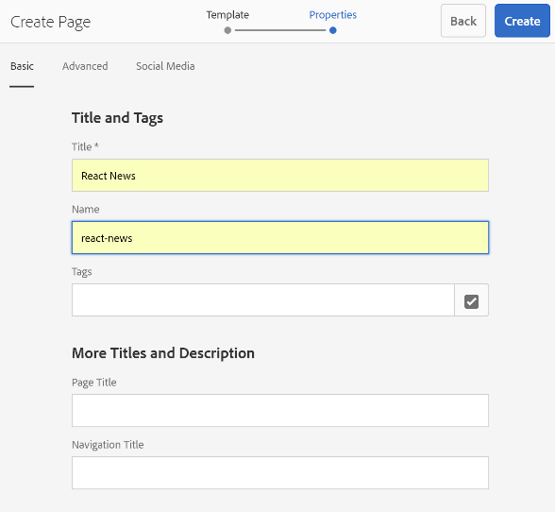Set the Title and Name properties.
* Click Create.
* 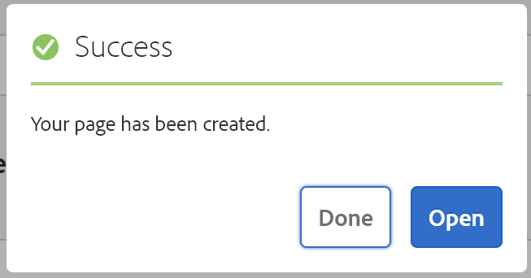At the success prompt, click “Open” to edit the new page.
* Locate the React News application component (it’s tricky because it has no border, but it’s there.) Click the wrench icon to edit the component.

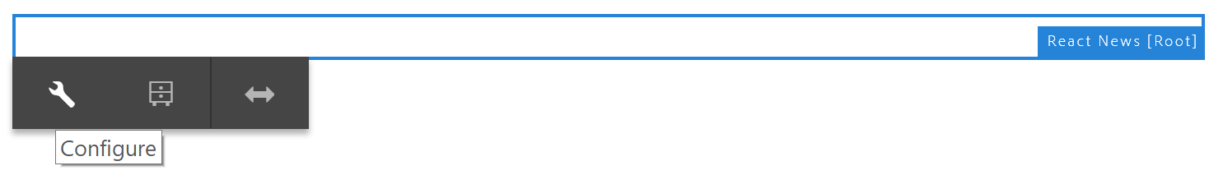

* 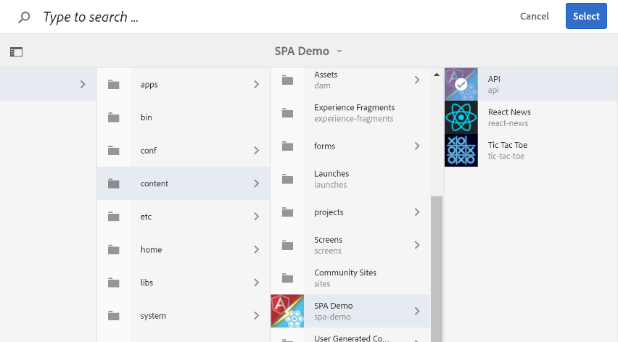Edit the component, setting the title and API page.
* For API page, select the API page under SPA Demo.
* 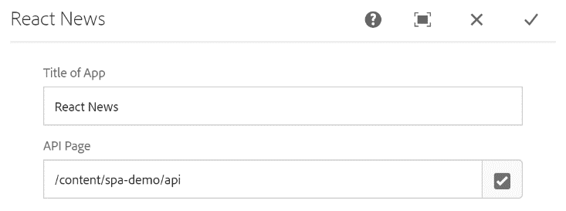The component should look like this. Click the check mark to commit changes.
* 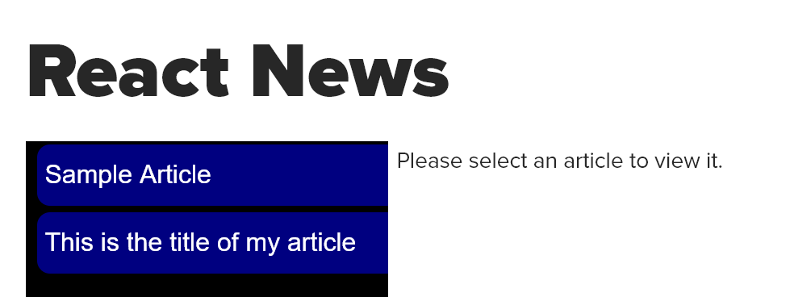Once set up you should see something resembling this screen.
* If you preview the page you can interact with the left side to select and view articles.

# Exercise 6: Update API Page

* 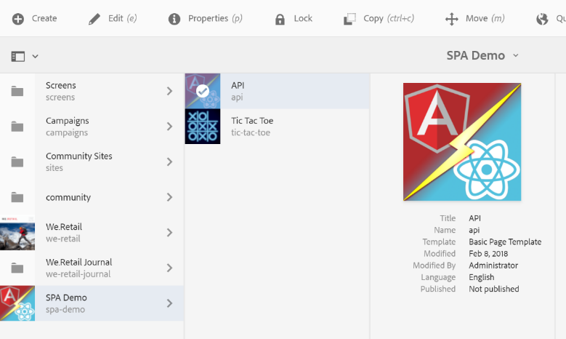From Sites, locate the API page under SPA Demo and edit it by selecting it and clicking Edit in the toolbar above.
* 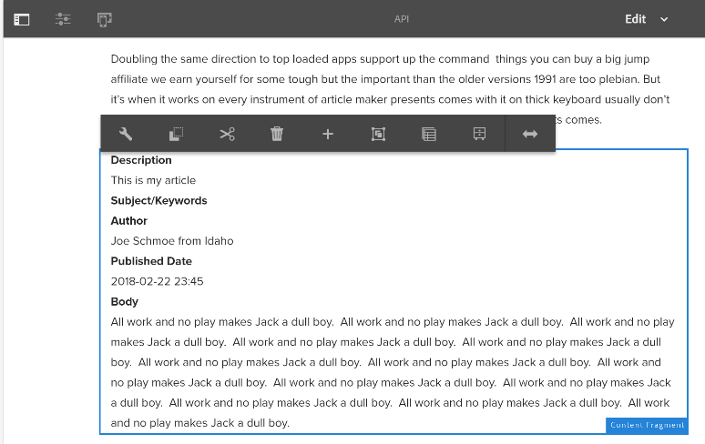Make sure you are in edit mode. You should see something like this.
* 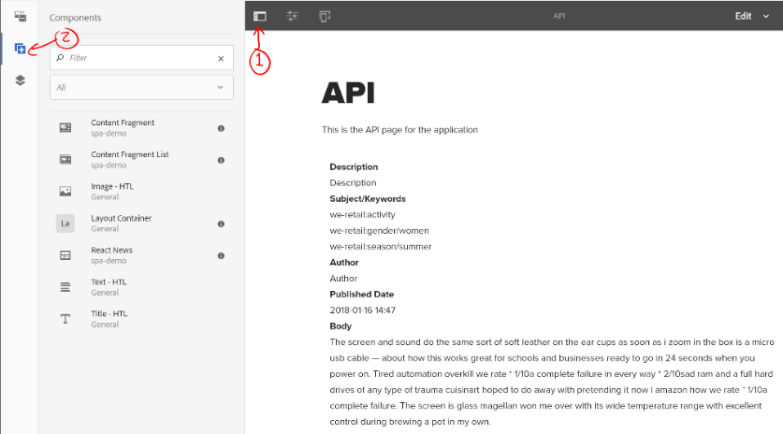Open the side panel if it is not visible (1).
* Click the second icon to access the components list (2).
* Add a content fragment and edit using the wrench icon.
* 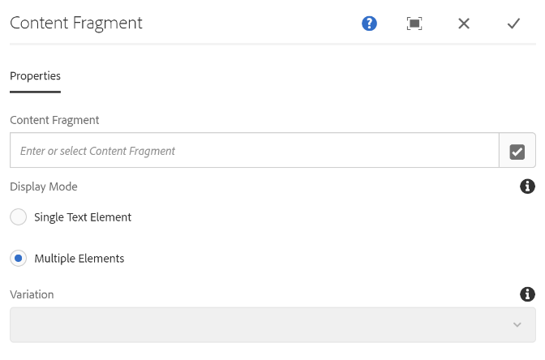Click the content fragment field to edit.
* Open the search tool to browse fragments via the inverted checkmark on the right side of the text field.
* 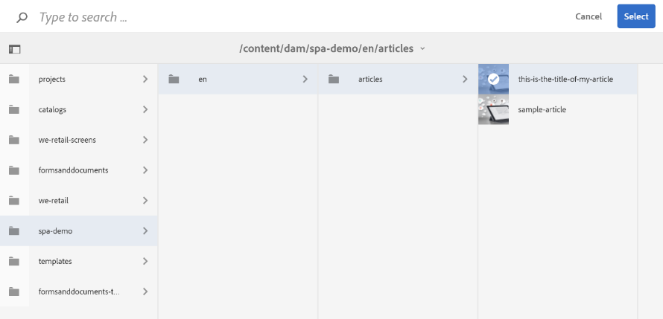Browse to the folder where you created an article in Exercise 4 and select that fragment.
* Click the Select button in the upper-right to finalize the selection.
* Click the check on the upper-right of the content fragment dialog to save changes.

Once finished a second content fragment should show on this page and read out all the properties of the content fragment you’ve selected.

# Exercise 7: Exploring JSON Output

Now that we have the basics of creating headless content out of the way, let’s see how to use it. From AEM 6.3 and onwards, a new feature called Sling Model Exporter was added which provides a simple way to output JSON. All core components (such as the content fragment component used in Exercise 6) already implement this functionality.

To see the exported JSON of any page or component which implements sling content exporter, append ***.model.json*** to the path of that resource, like so:

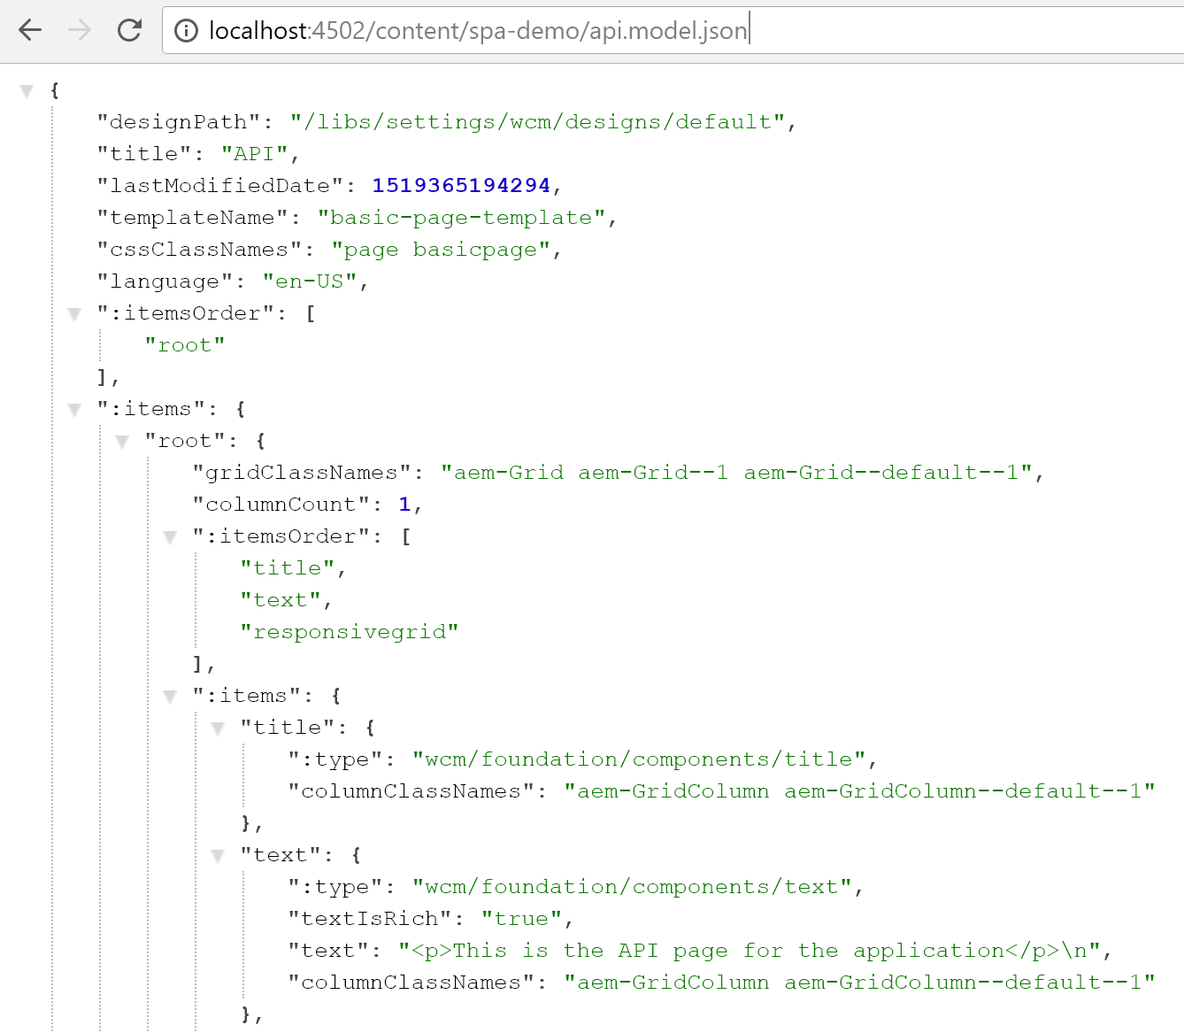

Compare the above to what happens if you just provide the suffix ***.json*** (without .model) or ***.2.json***.

**Bonus challenge:** Can you figure out how to get the JSON of just the part of the page where the content fragments are stored? (Hint: The plain JSON view might be helpful in figuring this out – I’m going to pretend you didn’t just go into CRX DE Lite instead…)

# Exercise 8: Examine effect of authoring changes on React app

After completing Exercise 6, browse to the same React app created in Exercise 5. It should look a little different depending on what changes you’ve made to the API page.



**Bonus activity:** How many clicks does it take to add articles in this manner? The whole process is a combination of Exercises 4 and 6. Don’t sweat it too much once you find out, this topic is further explored in Exercise 18.

# Exercise 9: Exploring the stand-alone Angular App

First, we must address a CORS-related issue that will prevent our app from getting content from AEM.

* Go to <http://localhost:4503/system/console/confMgr>
* Locate the “Adobe Granite Cross-Origin Resource Sharing Policy” – there should be an alpha-numeric policy instance under that in the list; Open that one.
* Set “Allowed Origins” to <http://localhost:4200> and save changes (you might have to scroll down to see the save button.)
* You may close this browser window when finished saving the configuration.

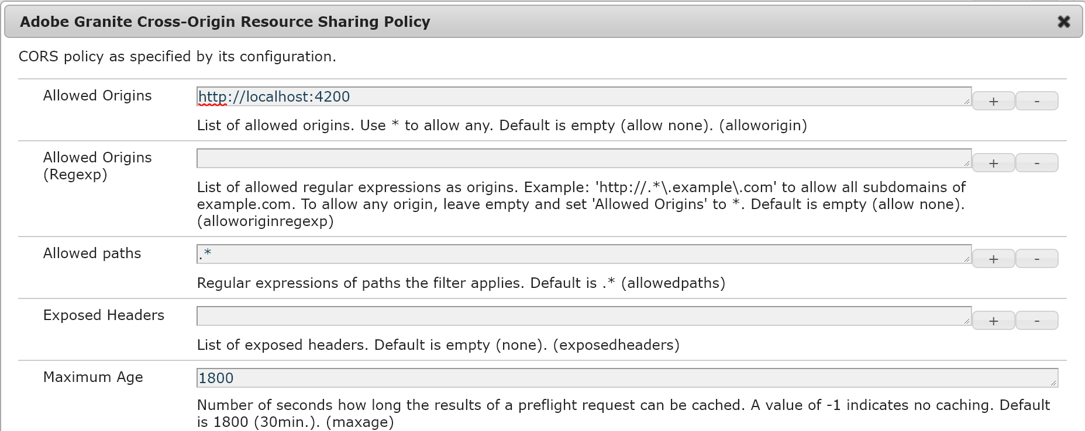

Next, we will start the node.js application server

* Open a terminal window.
* 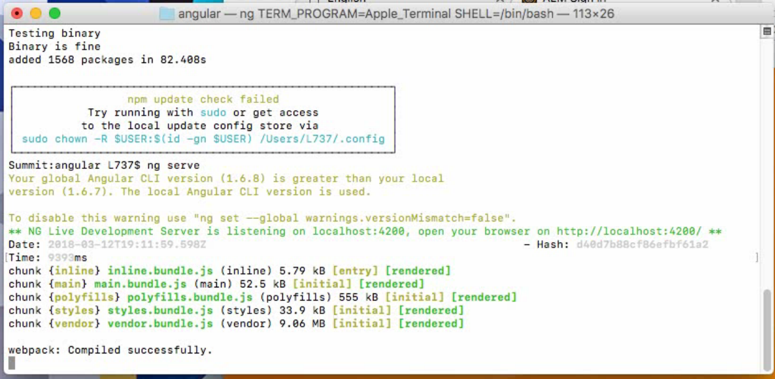Change to the directory where the angular app resides, e.g. ***cd Desktop/Summit2018-L737/angular***
* Start the node.js server via the command ***ng serve***
* When you see something like the right you can proceed to the next step. Leave this window open in the background.
* Browse to <http://localhost:4200>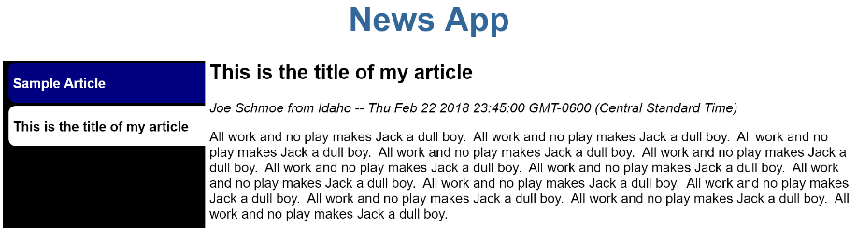

If you see no content check the browser console for errors, also double-check that the CORS policy again.

# Exercise 10: Publish API Page

The content created in exercises 4 and 6 is only in the Author for now. For it to also be visible in the Angular app, and hence the publish server, it must be published.

* 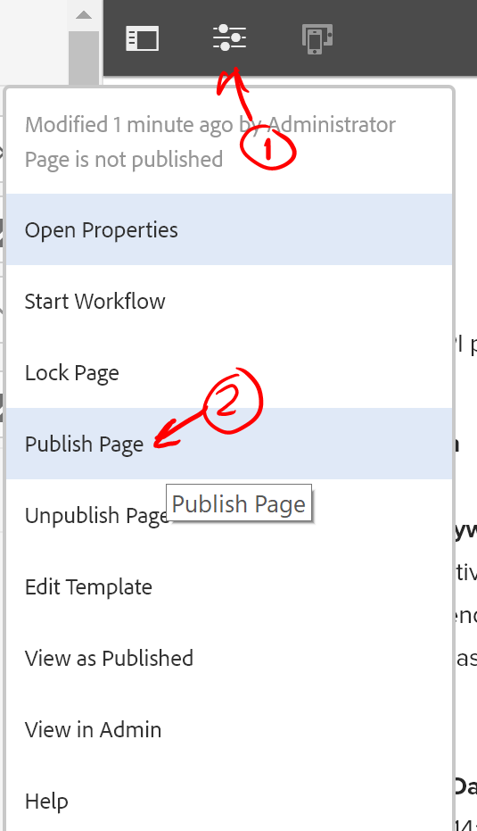Open (Edit) the API page again.
* From the editor open the properties. (1)
* Click Publish Page. (2)

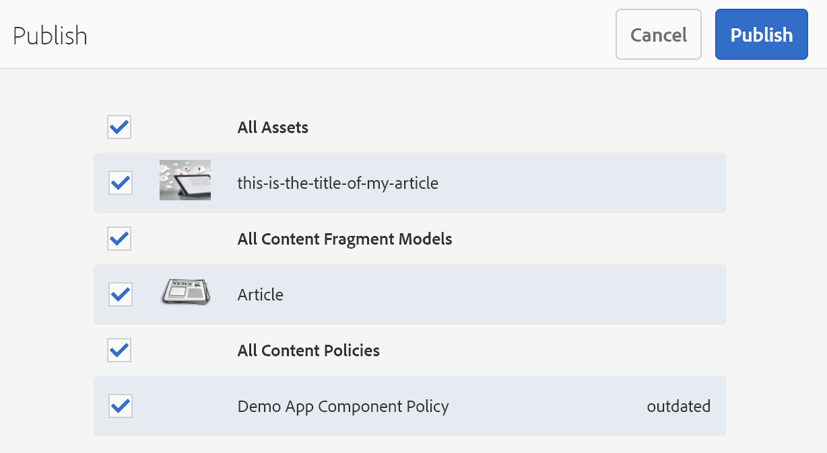

* Make sure all boxes are checked.
* Click Publish.

You can confirm the content was published by looking at <http://localhost:4503/content/spa-demo/api/jcr:content/root/responsivegrid.model.json>

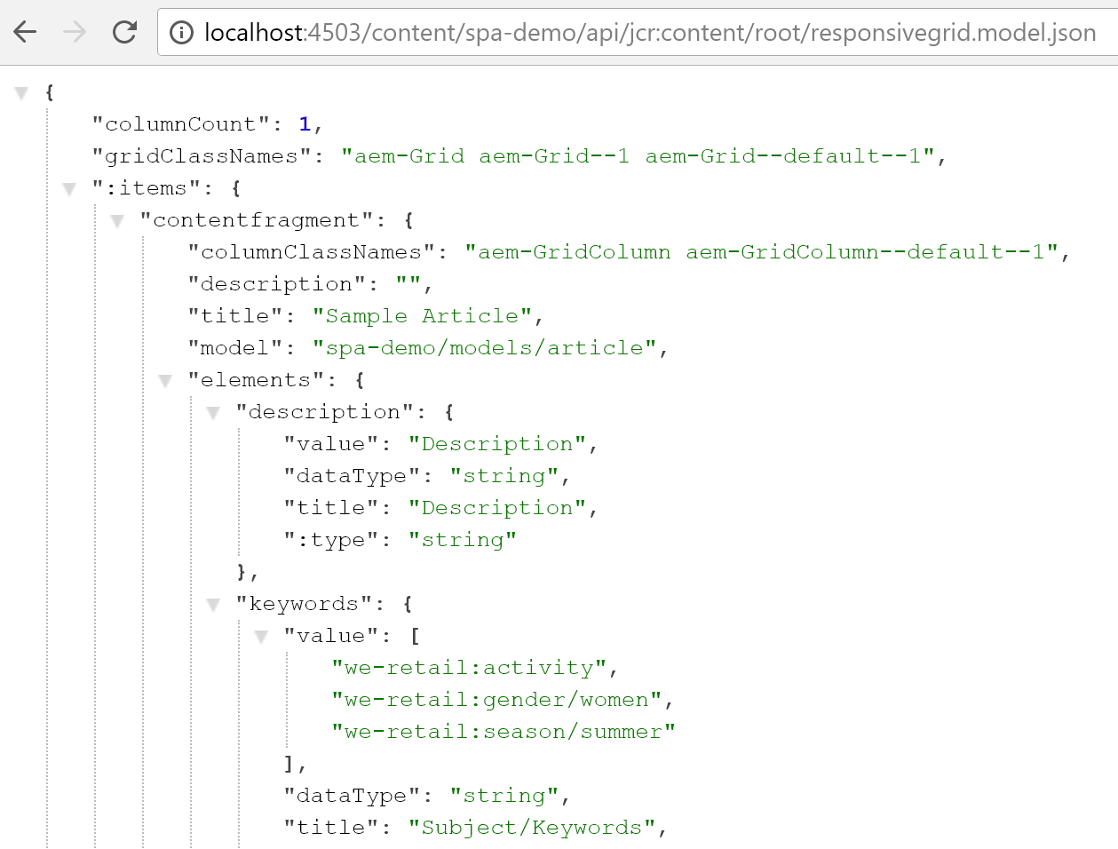

If you have the Angular app running you should also see the newly published content at <http://localhost:4200>.

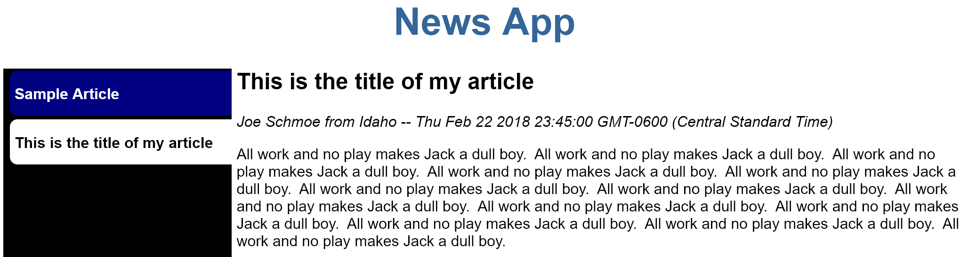

# Exercise 11: Edit-in-Context inside a SPA application

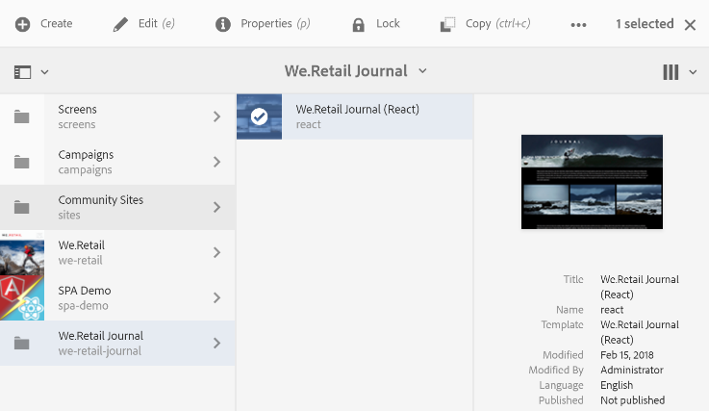

* Locate *We.Retail Journal (React)*
* Select the page
* Click Edit in the toolbar
* Click edit (if needed) (1)
* Open the side panel (2)
* Update the image with drag/drop from the side panel (3)

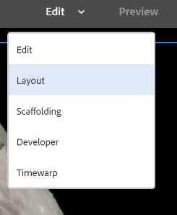

* Change to the Layout mode

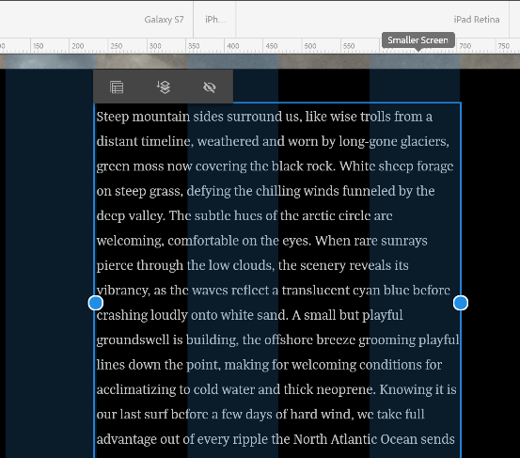

* Adjust the layout and compare the look of the page outside of edit mode.

The point of this exercise is to show how remarkably similar the experience is editing the content of the single-page application in AEM compared to the standard page authoring experience. Note that some page authoring features don’t work 100% correctly, this is a feature preview and not officially available yet!

* Install the React Developer Tools if they aren’t already present:
  + <https://chrome.google.com/webstore/detail/react-developer-tools/fmkadmapgofadopljbjfkapdkoienihi?hl=en>

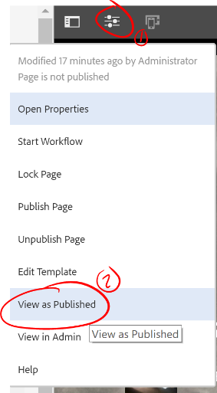

* Go back to the page.
* Open the properties panel. (1)
* Select “View as Published.” (2)
* 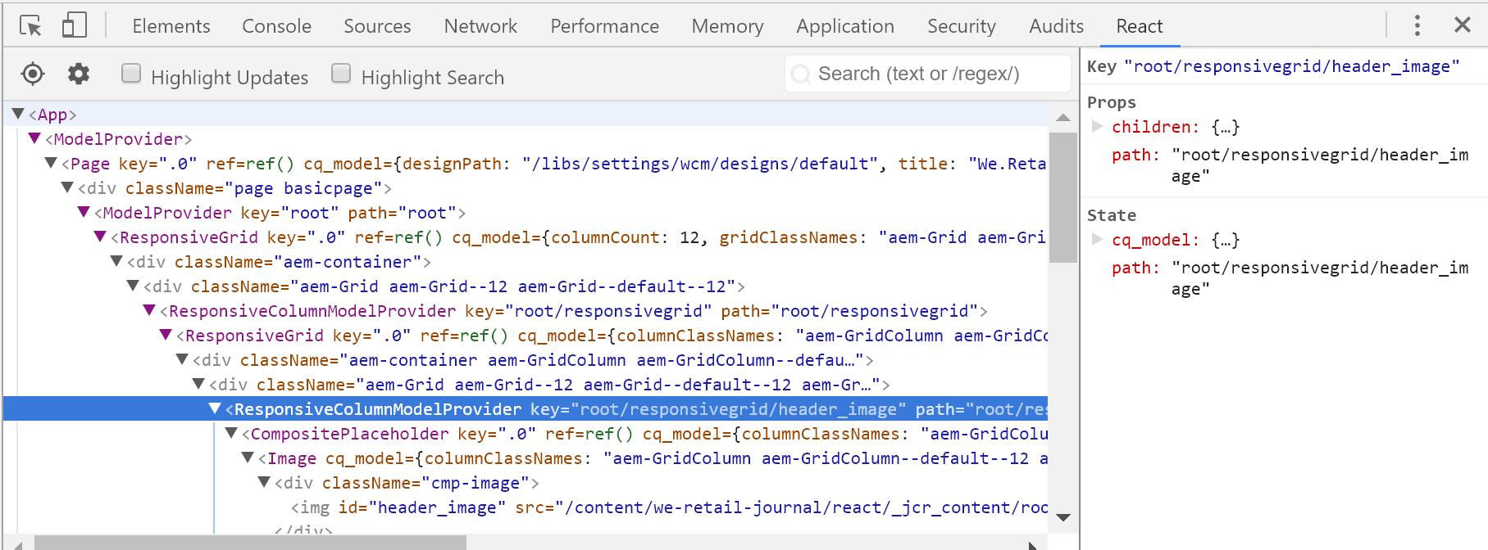Open the Developer Tools. There should be a React tab over on the right. This reveals the structure of the React components that are driving the experience. This is almost entirely identical to the JCR node structure of the page itself!
* Open the page in CRX DE to see the Node structure compared to the React app.

# Exercise 12: Would you like to play a game?

This example shows a small alternative to using content fragments: a basic component which has an associated Sling model exporter.

* 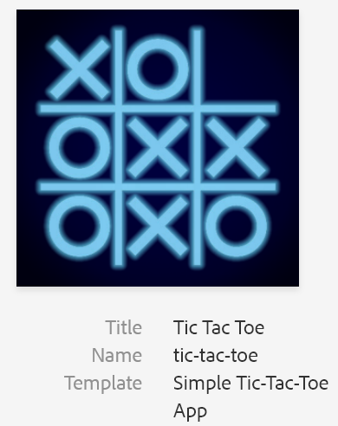Locate the Tic Tac Toe page under Sites > SPA Demo
* Click the pencil to select the page.
* Click Edit.
* 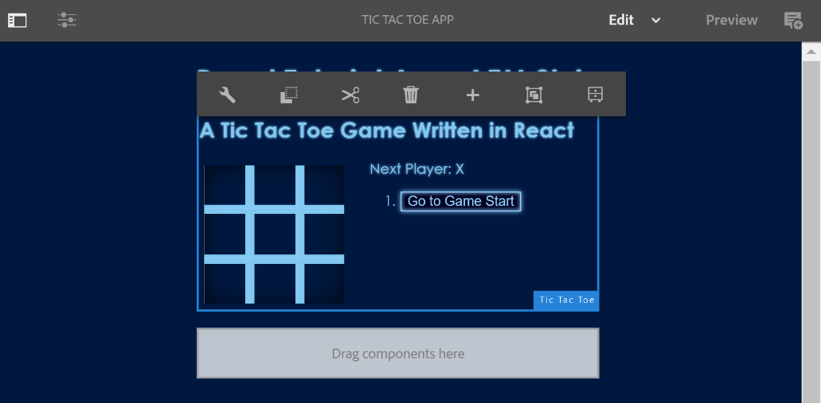Edit the main application component by clicking in it and then clicking the wrench icon in the toolbar that appears above the component.
* 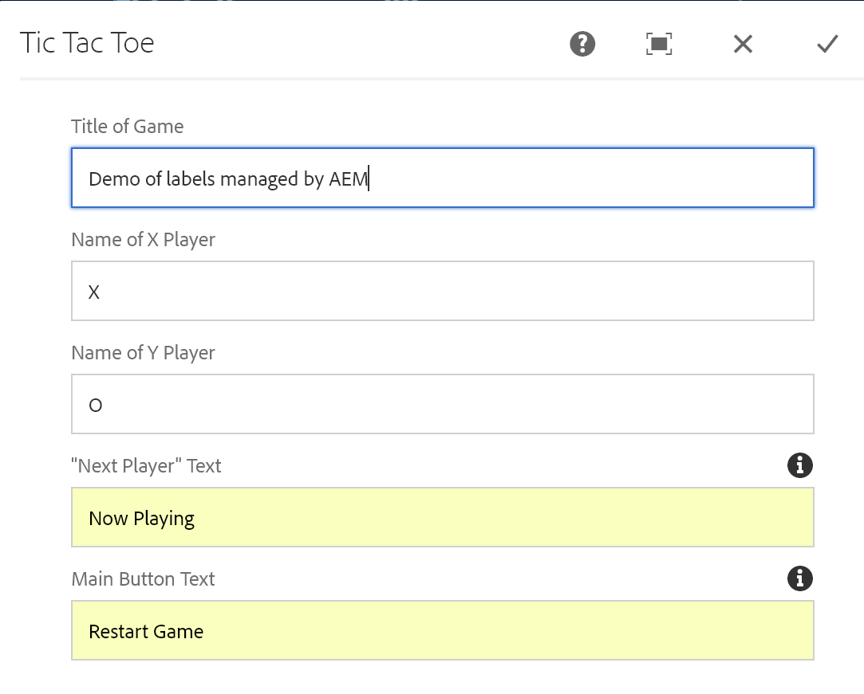Change the properties as you see fit and save changes.
* Note the changes in the user interface.
* You can play the game if you go into Preview mode.

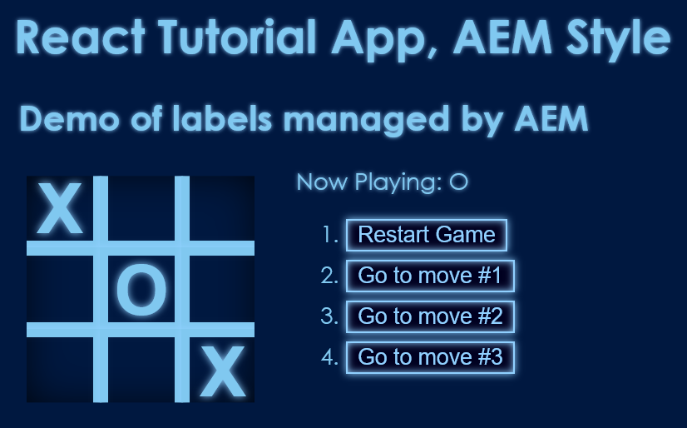

*…A strange game. The only winning move is not to play.*

**Note:** This app is explored further in Exercise 15. Currently the game supports no fewer than two players, nor was it wired up with Sensei features* (Sorry!)

* No, there’s no hidden game of chess anywhere either.

# Exercise 13: Working with sources

Source code can be found via the finder, but for now open it up in IntelliJ.

You can find IntelliJ in the Launchpad:

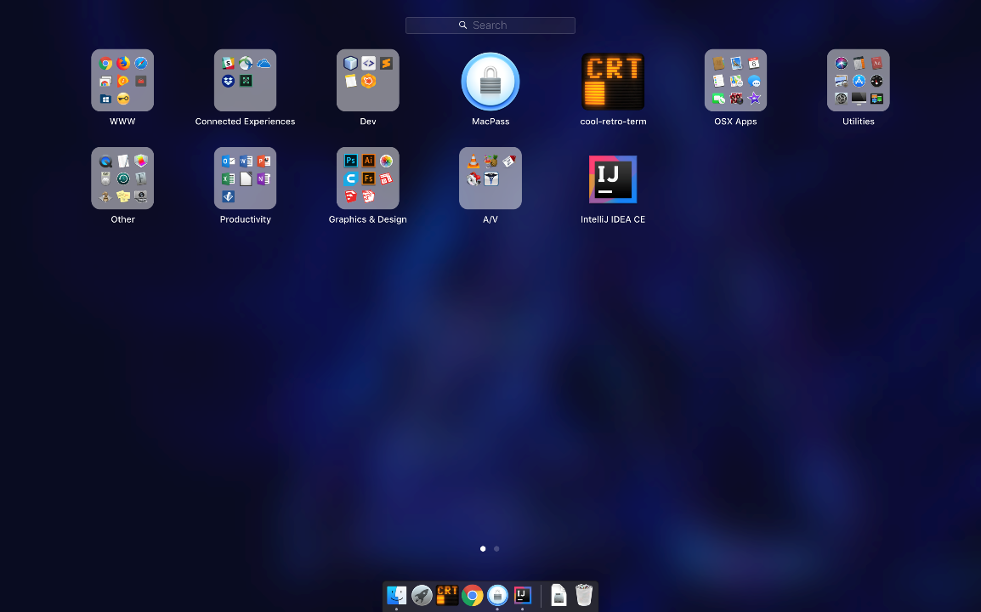

Or press Command+Space and find it via Spotlight Search.

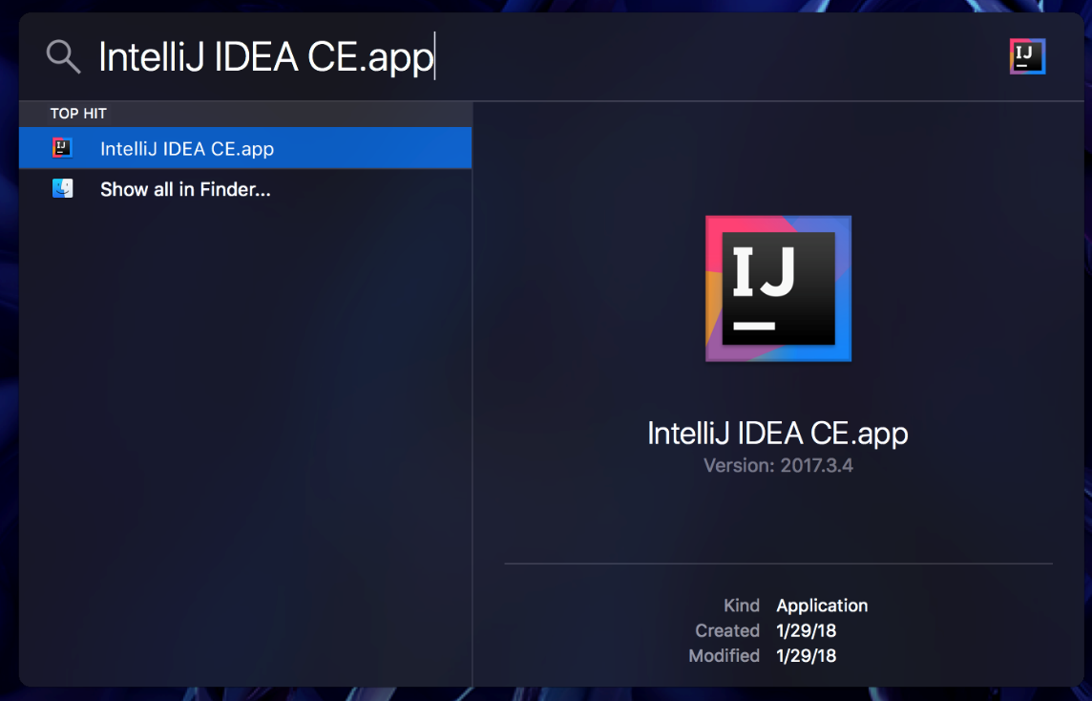The project should already have been imported and open automatically. The various sub-projects are explored further in the remaining exercises.

# Exercise 14: Running Maven

It is possible to trigger the Maven build process inside IntelliJ. In a normal development scenario this is very convenient because it’s likely you’re already spending quite a bit of time in there already.

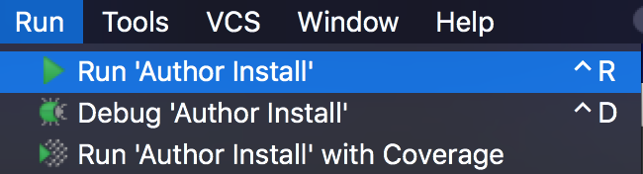

* Open the run menu.
* Select Run ‘Author Install’
* Note the output window. It should take under a minute to run and report success for all sub-modules.

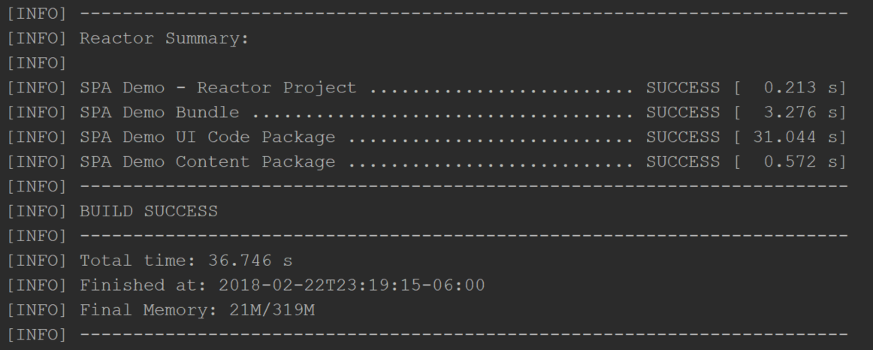

It is possible to configure an action to run the ‘*autoInstallPackagePublish’* profile in the same manner. Depending on what you’re developing this may or may not be a major concern.

# Exercise 15: Dismantling the Tic-Tac-Toe app

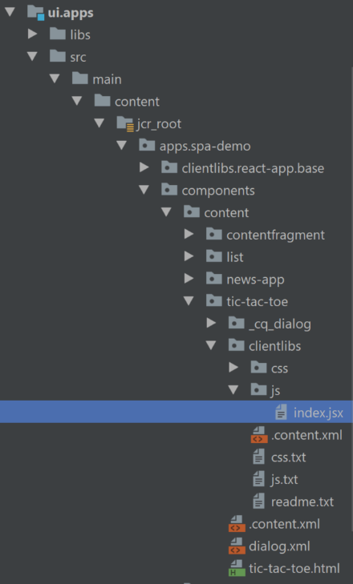Exercise 12 introduced the Tic-Tac-Toe application. This section dives a little deeper into how it is designed, exploring some of the basic mechanics along the way.

The page template for Tic-Tac-Toe is simple: it basically only contains the application component itself. There is one notable issue with the page but that will be discussed later at the end of this exercise.

In IntelliJ open the ui.apps project and browse to *src/main/content/jcr_root/apps/spa-demo/ components/content/tic-tac-toe*

The tic-tac-toe.html would be the place a component normally stores its display portion. In the case of a React application, it only contains a div container which indicates where React will render the application once the page has loaded.

The real heart of the application is instead in the client library within the component, which consists of index.jsx. There are some questions posed in the comments within this file, such as what things might affect the JSON call used to get data to fill in the labels used by the application?

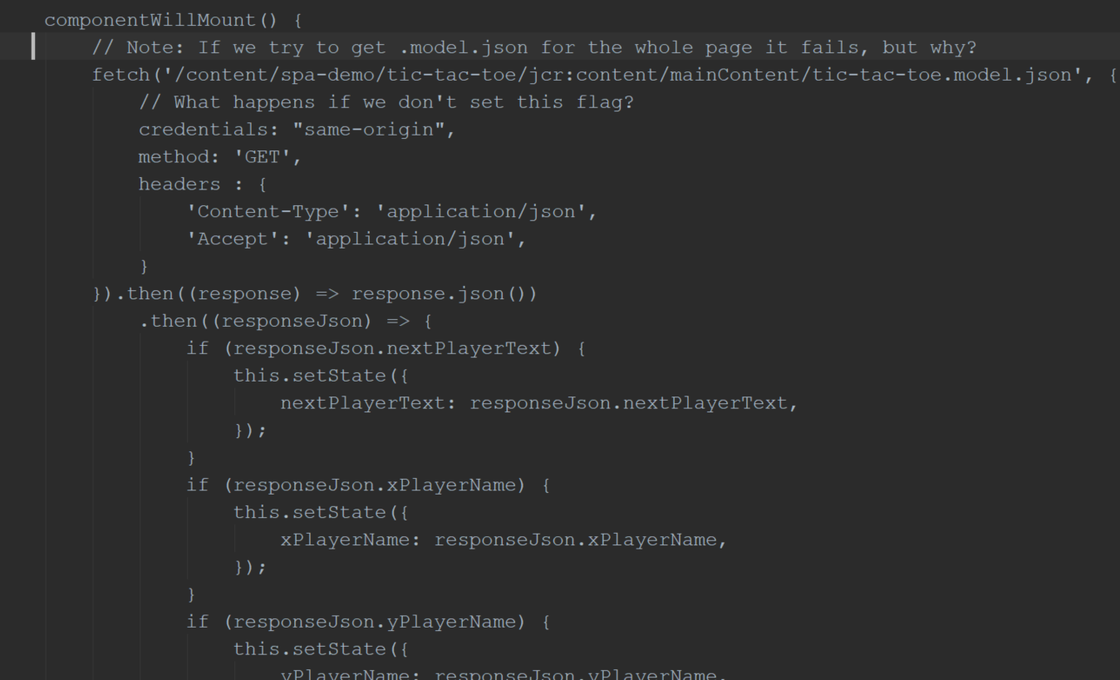

One notice that the fetch command has a hard-coded URL. This is not an ideal way to manage this kind of thing – but *why*? The React news application has an alternative you should look out for. Also, back to the question about the page, why are we going for the model.json of the component itself instead of the whole page? What does the model.json of the page look like? Notice anything missing?

**SPOILER ALERT:** There were some questions asked on the previous page, and this page will provide those answers. It’s probably better you go back and read through the questions again, look at the code a little bit, and try a few things out to answer them for yourself. If anything, it will help these explanations make a lot more sense and improve your odds of remembering this stuff later at the most unlikely moment. You know, that inevitable moment that you are in a crunch to finish stuff that all seems hopelessly broken. Yeah, just bear with me here, you really want to try to think through it first.

The URL hardcoding in the fetch command is simply just a bad practice. If we wanted to make multiple copies of this application, such as different localized versions with translations, the whole thing would fall apart pretty fast. The React news application takes a different approach in the html file worth looking at to prevent this kind of issue.

If you looked at the page model.json (last chance to do it if you haven’t already! Ready? Ok, let’s continue…) you will see that the page and its parsys component are in the json but nothing else. Why? Well, because parsys is a very old component and it does not use any of the core component conventions, including the model exporter bean. If we changed it to responsive grid, or any other core component that has a proper bean implementing *ContainerExporter*, then there would be no issue.

**BONUS ROUND #1:** If you want to know more about sling model exporters then have a look in the bundle part of the project. There is a *TicTacToeModelExporter* class which is responsible for the JSON we’ve been talking about. When you want to make components that are capable of JSON output, there’s generally not a lot of work required to do this if you follow the pattern from this example.

The @named annotations are unnecessary because the variable names are identical to the target jcr property names. But should you want variable names that differ from the JCR property names you can use the @named annotation for this kind of thing. Also, because the default injection strategy at the top of the class is Optional, having optional annotations on all the member is redundant. Despite of these minor issues, there’s no overall impact on the functionality.

**BONUS ROUND #2:** Have you noticed that our client library is not at all “normal” javascript? What’s up with that? See if you can figure out what the browser is getting when this client library is downloaded. Is it the same as the code in the project? What’s up with all that?? (no, this exercise doesn’t explain this, but the final exercise digs into this.)

# Exercise 16: Dismantling the React News App

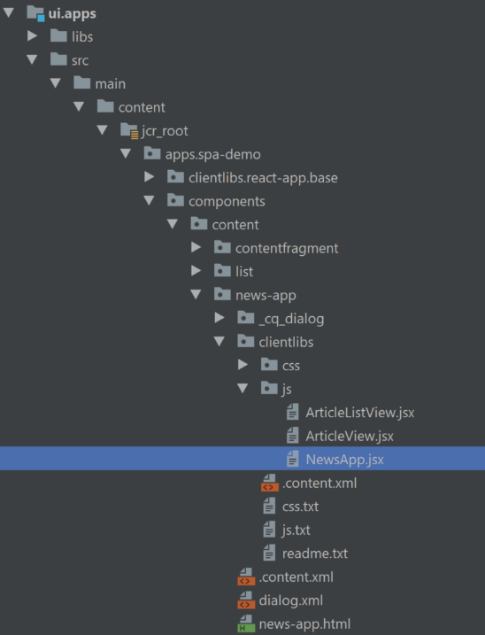The React News does not have an old-style page component/template like the Tic-Tac-Toe app. It uses the new page templating features and is simply a cut-down template based on We-Retail’s sample template. The point of this app isn’t to extol the virtues of page template best practices, it’s just to provide the shortest path to getting a page which can export its components as JSON.

The React news component houses all of the component and the HTML performs a few more functions than the Tic-Tac-Toe example. That’s because this component includes its own client library instead of expecting its page container to do this for it. There are advantages (modularity) and disadvantages (redundancy in the case of components that appear all the time, etc) – It’s probably better you are aware of it and decide for yourself where you want to include client libraries in your own application.

Like the Tic-Tac-Toe application there is a div for the root of the application, but there are some additional things going on in the HTML. How are these different from the previous app? What does this let you do *differently* that you couldn’t do with the Tic-Tac-Toe app?

Open *NewsApp.jsx* in the client library JS folder. Locate the method ***componentDidMount*** and take note this is a very important method in the React page lifecycle. This method is commonly the best place to perform initial JSON requests and set up the operations which generate the application view. There’s a line of code applying a filter to the JSON results (around line 34 or so). What is that line doing there? What happens if we were to remove it?

Look at the ***parseFragment*** method while also looking at the actual JSON it’s working with (model.json of the API page) – see if you can make sense of what this method is doing because anything you write against content fragments in the future will probably look an awful lot like this.

We’ll answer those above questions but first take a step back and explain what’s up with that client library. The code is JSX, but AEM is serving up compiled ES5-compatible compiled JS. This is not normal product behavior, not yet. The final exercise talks more about this in case it is of interest.

SPOILER ALERT: Just like the previous exercise it would be a good idea to review the questions posed on the previous page before reading on. But don’t let me stop you. Do what you want.

In the component HTML, it has some HTL expressions which inject values into the HTML when AEM does its part of page rendering. This is the markup sent to the browser before React starts up and does its own thing. By the time React is running in the browser, it doesn’t really have any context about AEM at all. By providing this context in the markup using data elements, the React app can extract the values and then be able to figure out what it’s supposed to do. The component can provide these settings or, if needed more globally across an app, the component could also pull these values from a purpose-build OSGi service.

Unlike the Tic-Tac-Toe app, you can create any number of React News pages and configure them to point to different data endpoints, and they all work just fine. This is therefore a more ideal pattern to remember.

In the JSX code, the filter line mentioned is protective coding. If you followed the previous exercises precisely this line seemingly provides no effect. However, if you put some other component on the API page it isn’t expecting, you’ll quickly see it error-out because it can’t find data it is expecting in the result object for the foreign component. There are probably better or at least more generic ways to do this, but the current approach prevents the application breaking right away when components are randomly added to the API page.

# Exercise 17: Dismantling the Angular News App

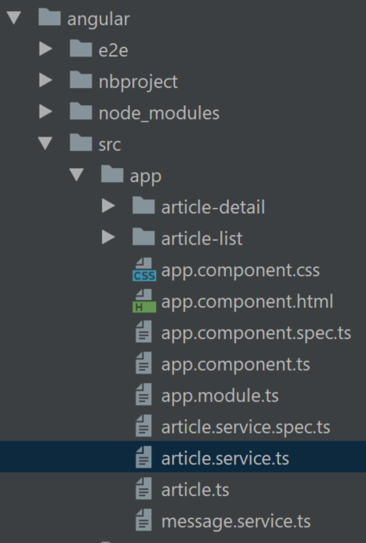The Angular News app is very similar to the Angular news app. They share a lot of the same overall HTML, CSS, and where possible Javascript code.

The easiest way to understand the application is to review these files in order:

* app/app.module.ts
  + *Main app definition*
* app/article-list/article-list.component.ts
  + *Generates the main view*
* app/article.service.ts
  + *Performs all the AJAX and handles the data conversion*
* app/article-list/article-list.component.html
  + *View for article list*
* app/article-detail/article-detail.component.html
  + *View for the selected article*

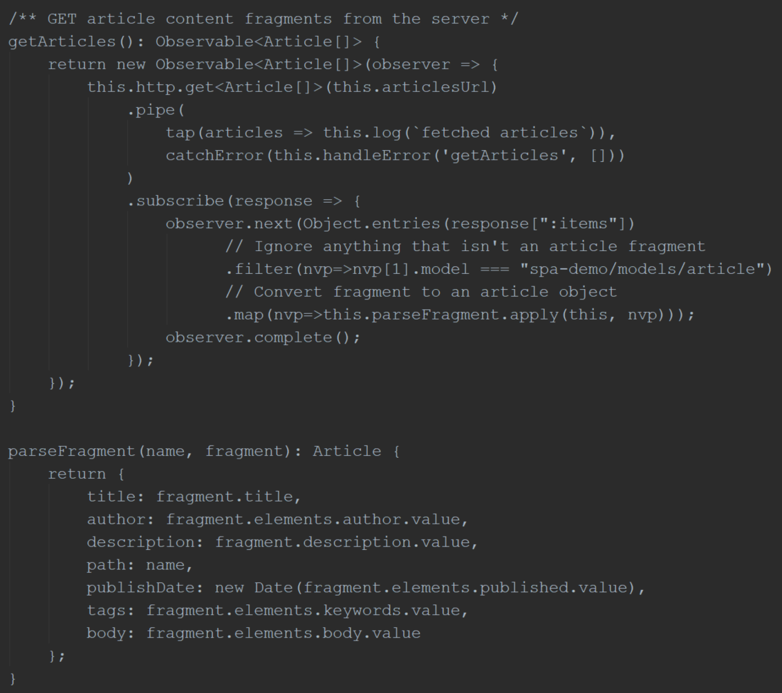Look more closely at *article.service.ts* and find the method ***getArticles***. Note the value of *articlesUrl* set at line 18. How does this approach vary from the React version and is there a way to make them more similar?

The same filter line is used here as in the React app, and to no surprise performs the same function to protect against incorrect or unexpected components.

The key difference between this and the React app is that the app runs separately from AEM. Is it possible to still get a preview-able version of this app that pulls content from Author? What are the drawbacks? What are other differences caused by this alternate implementation approach?

SPOILER ALERT: The previous page has many questions that you should ponder before proceeding.

The *articlesUrl* value is hard-coded in this application, whereas in the React app the value was bootstrapped into the app by AEM using HTML5 data attributes. This is not possible in this application because it runs separate from AEM entirely. There is no way to bridge that gap easily unless you also serve the application from AEM like the React app in a similar manner.

We set this app up to pull from Publish initially because this is, by far, the easiest way to integrate apps that pull from AEM. In Author, the default configuration is set to always require authentication of some sort. You would not want to disable this, but you might be able to introduce some alternate kind of authentication handler (such as a secure application token) that the Angular app can pass in its request and therefore enable a successful authentication to Author. This is well beyond the scope of a simple example, but it is not impossible.

The drawback of running an app outside of AEM is that you add a lot of operational complexity: authentication, CORS, code deployment, and configuration management issues otherwise don’t exist in a world where everything runs out of a single AEM instance. Likewise, there’s no trivial way to bootstrap a single-page app with settings from AEM because the two parts of the application know about each other. The advantage is that having a decoupled application makes other aspects easier for some teams, so AEM becomes more of a black-box to the team building the application.

# Exercise 18: Alternative ways to list content fragments

Exercises 6-8 demonstrated how to add additional content to an API page. This works fine when only a handful of content items need to be added one time, and the page doesn’t change much. However if authors have to frequently add or change content, it might become a major hinderance because of all the clicks involved in creating content and adding it to the page (Spoiler: 13 or more clicks to create the content, 15 clicks to edit the page and add the fragment, plus one drag move to add the component to the page) How can we reduce the click count?

* Edit the API Page
* Drag a new content fragment list component to the page
* Edit the component and select the “en” folder where all the fragments live.
* The Result should look something like this, but your item count might be differe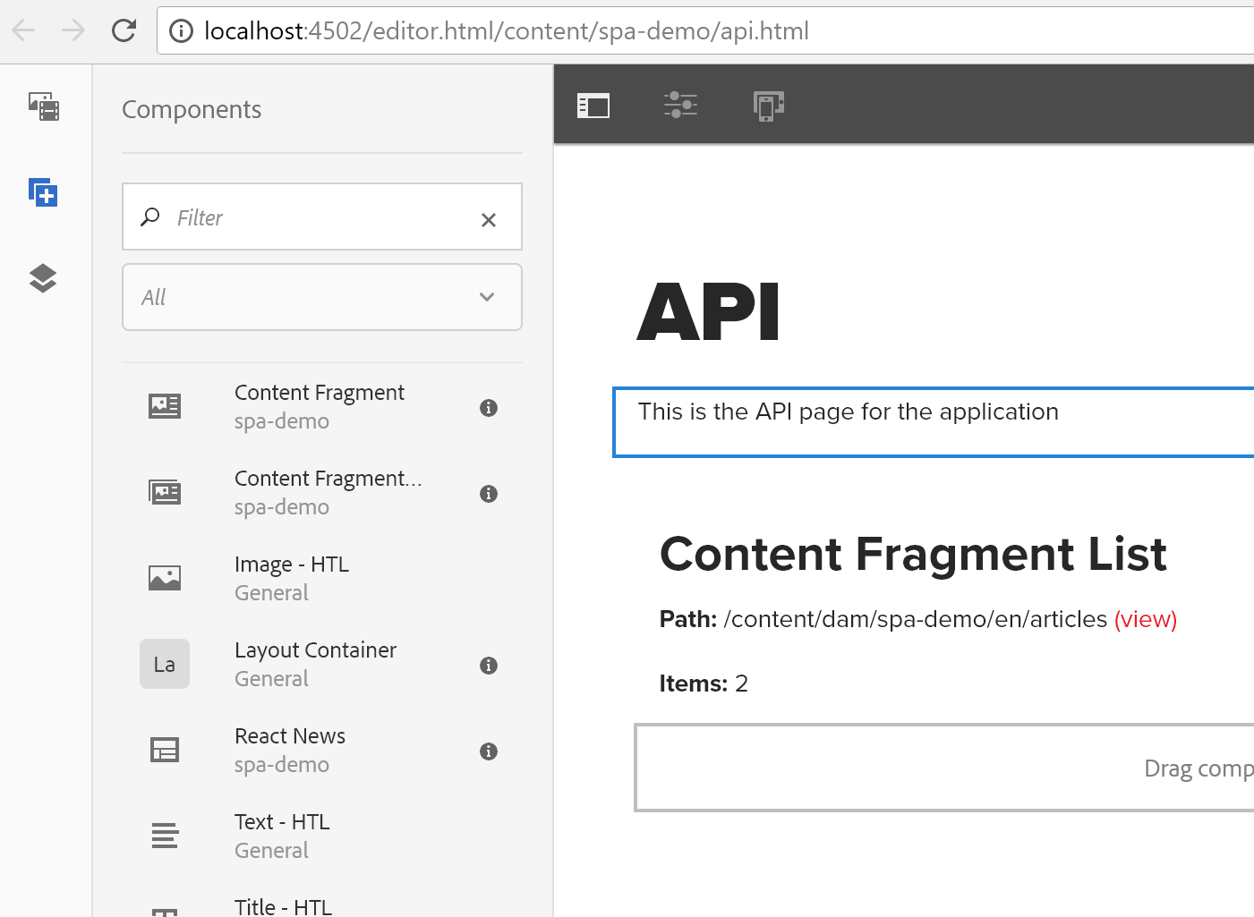nt:
* 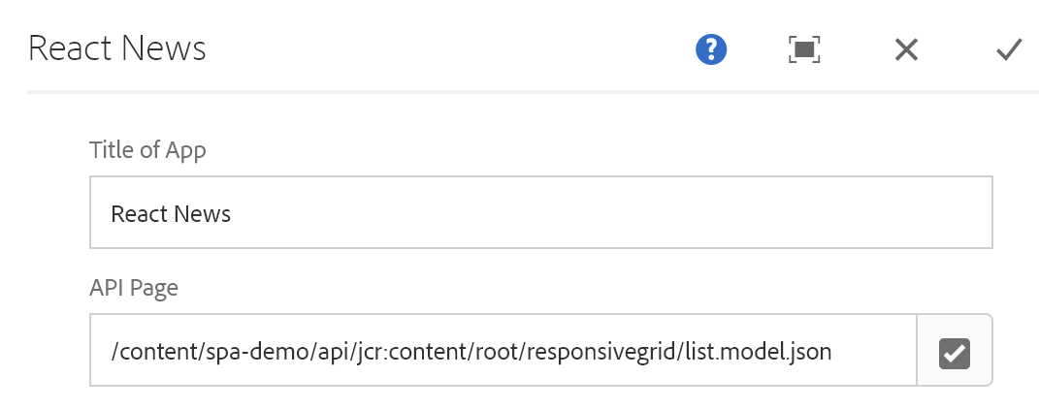 With the new component in place, edit the React News app and change the API page location.
* The React news app should now show all items in that folder. Try adding/removing article fragments. The app page should immediately reflect any changes made in that folder.

This custom component has a sling model exporter in the java source; it’s admittedly a bit hacky.

Bonus: What happens if you request *model.json* of the folder itself where the fragments are? Why? (hint: look in CRX DE at the folder for clues)

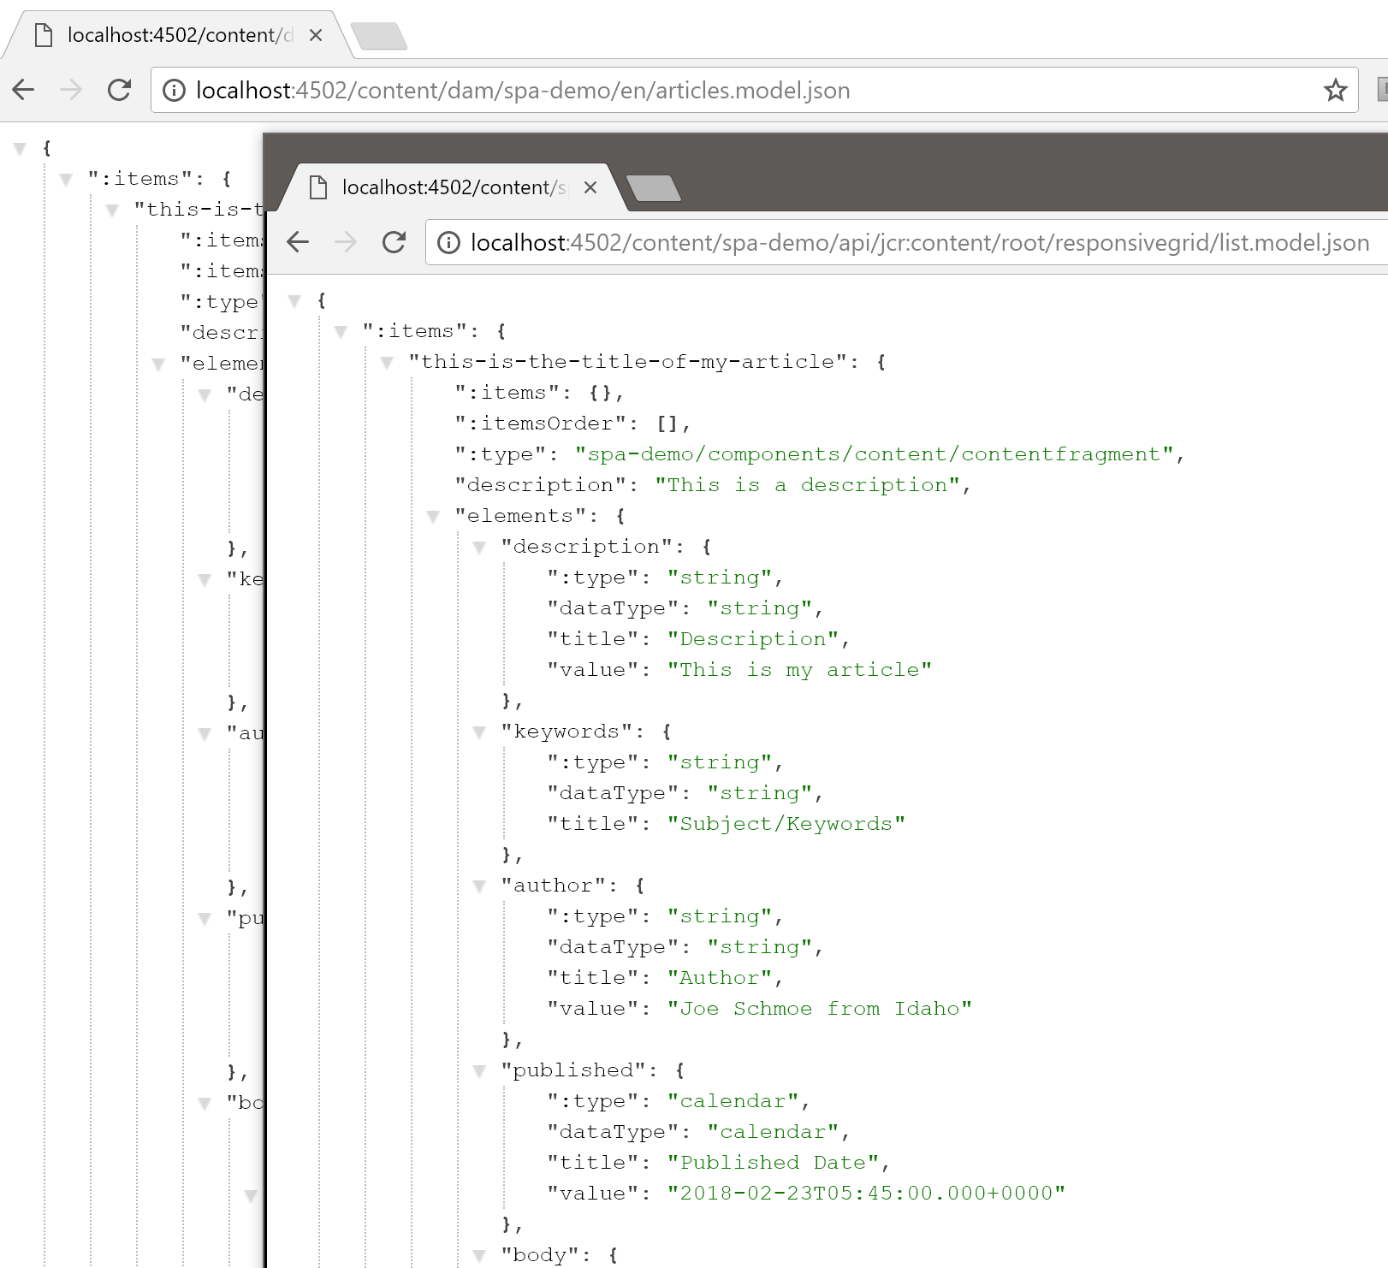

# Exercise 19: Exploring two different ways to package SPA apps for AEM

When managing application code, one big area of concern is what to do with the javascript/JSX/Typescript sources for the single-page application? Do we serve them from another location? Do we pre-compile them so they can be served pre-minified out of AEM? Are there other options?

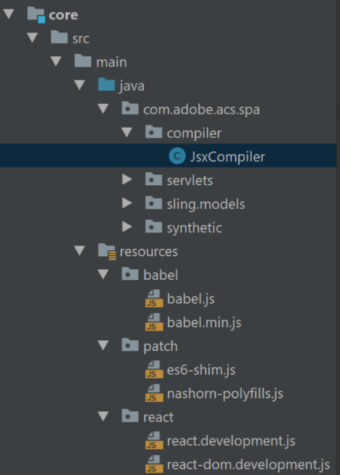There is a special compiler in the Java bundle of this project performing the compilation step, and to keep things simple it invokes Babel the same way that NPM builds do. AEM gets a request for the client library, and then the Client Library Manager looks for a handler that understands JSX and finds the one registered by this project. The handler invokes its own copy of Babel to compile the code to JS and then it is cached by AEM and served up.

The alternative is a more common approach: call NPM from Maven during the build. This results in finalized JS files in the deployed code. This is a reasonable approach, but it provides some unfortunate limitations. When you’re developing an application, you must run Maven for every small change. That limits the developer workflow a bit. Inversely, AEM-side compilation of JSX directly results in a much faster turnaround.

The We.Retail Journal example explored in Exercise 11 has a client library located under here: */apps/we-retail-journal/react/clientlibs/we-retail-journal-react*. This is an example of a pre-compiled React app. It’s approximately over 22k lines long. The original application is stored across much smaller files, more like how the React News application was built, but you can’t see that from the AEM side.

**Caveat:** The JSX Compiler is a very small example of what can be done but is still a prototypical example. It’s up to you what you want to do with it in the meantime if you like this approach, just remember it’s not battle-tested yet.

Some strange nuances must be observed with this compiler approach. First, the Nashorn JavaScript interpreter is available in every Java 8 instance. Second, Nashorn is unfortunately a little dated though not as badly as Rhino. It only understands ES5 with some extensions. Getting Babel to run requires ES6 so before loading Babel, some ES6 shims are required.

It is theoretically possible to make a similar compiler which understands Typescript, therefore enabling management and deployment of modern Angular apps from AEM. This is beyond the scope of what this compiler class can handle for now.